**DATABASE MANAGEMENT SYSTEM ASSIGNMENT -II**

**Name:** Bharathwaj. M

**Roll no:** RA2011026020065

**Dept:** CSE with specialization in AIML

**Year/Semester:** 3rd/6th

**ENTITY RELATIONSHIP DIAGRAM**

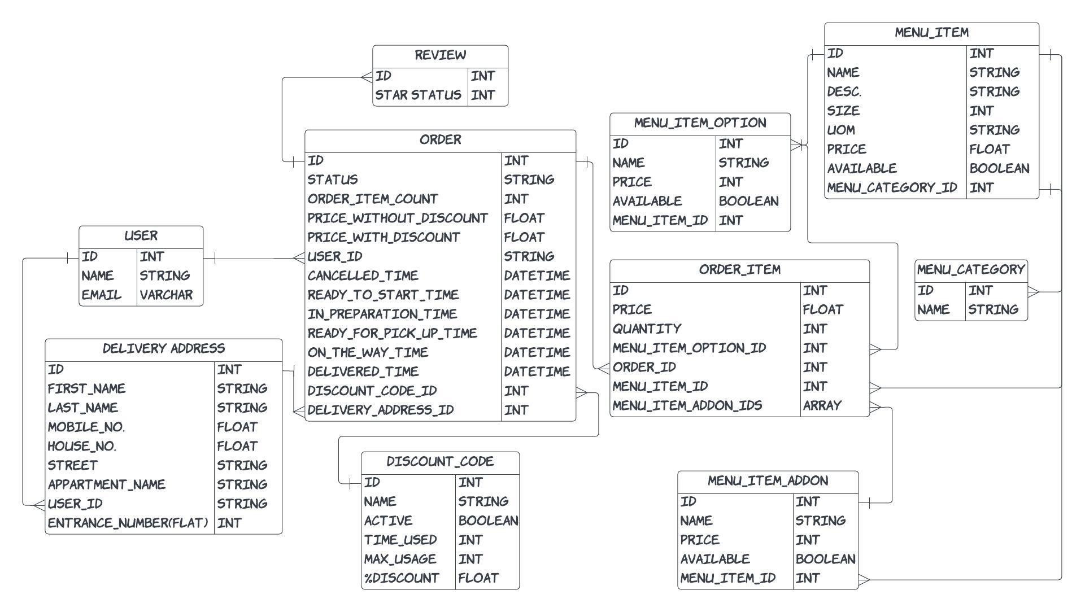

**HOW IT WORKS:**

1. A user places one or more orders with certain intervals.
2. An order can contain one or more food Items from the same or different restaurant.
3. An item belongs to one restaurant can be placed from their menu option (available for each respective restaurants).
4. The user can apply discount coupon, if available.
5. From specific restaurant if the user order items from menu and also, they will be presented with option of including add-ons to the food placed for order.
6. Finally, the order will be placed for one or more food items with or without discount applied.

**DESCRIPTION:**

In this ER Diagram, we have 9 entities:

* User,
* Delivery address,
* Order,
* Order item quantity,
* Discount code,
* Review,
* Menu item,
* Menu item option,
* Menu category,
* Menu item add-on.

**ATTRIBUTES:**

* **User Entity:**

01)Id,

02)Name,

03)Email.

* **Delivery_address Entity:**

01)Id,

02)First_Name,

03)Last_Name,

04)Mobile_No,

05)House_No,

06)Street,

07)Appartment_Name,

08)User_id,

09)Entrance_No.

* **Order Entity:**

01)Id,

02)Status,

03)Order_item_count,

04)Price_without_discount,

05)Price_with_discount,

06)User_id,

07)Cancelled_time,

08)Ready_to_start_time,

09)In_preparation_time,

10)Ready_for_pick_up_time,

11)On_the_way_time,

12)Delivered_time,

13)Discount_code_id,

14)Delivery_address_id.

* **Order_item_quantity Entity:**

01)Id,

02)Price,

03)Quantity,

04)Menu_item_option_id,

05)Order_id,

06)Menu_item_id,

07)Menu_item_addon_ids.

* **Discount_code Entity:**

01)Id,

02)Name,

03)Active,

04)Time_used,

05)Max_usage,

06)%Discount.

* **Review:**

01)Id,

02)Star Status.

* **Menu_item Entity:**

01)Id,

02)Name,

03)Description,

04)Size,

05)UOM, #Unit_of_measure

06)Price,

07)Available,

08)Menu_category_id

* **Menu_item_option Entity:**

01)Id,

02)Name,

03)Price,

04)Available,

05)Menu_item_id.

* **Menu_category Entity:**

01)Id,

02)Name**.**

* **Menu_item_addon Entity:**

01)Id,

02)Name,

03)Price,

04)Available,

05)Menu_item_id.

**UNDERSTANDING MAPPING CARDINALITIES:**

**(ONE-TO-ONE RELATIONSHIP)**

In this ER Diagram, the entity **ORDER ITEM** is associated with the entity named **MENU ITEM**.

**(ONE-TO-MANY RELATIONSHIP)**

In this ER Diagram, the entity **USER** is associated with the entities **DELIVERY ADDRESS** and **ORDER.**

Similarly, the entity **ORDER** is associated with the entities **DISCOUNT CODE, REVIEW** and **ORDER ITEMS.**

In the similar accounts, **MENU ITEM** is associated with the entities with **MENU ITEM OPTION** and **MENU ITEM ADDON**.

**(MANY-TO-ONE RELATIONSHIP)**

In this ER Diagram, the entity **MENU ITEM** is associated with the entity named **MENU CATEGORY**.

Same as above, the entity **ORDER ITEM** addon is associated with the entity named **MENU ITEM ADDON**.